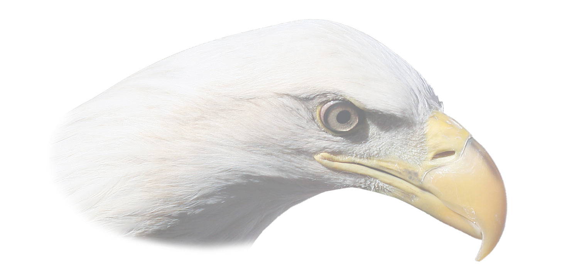
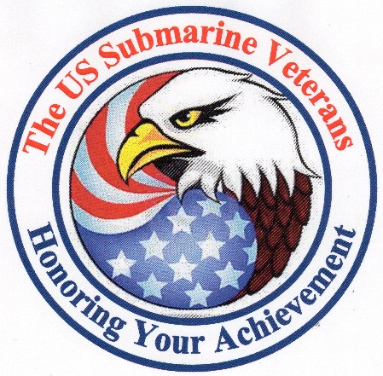
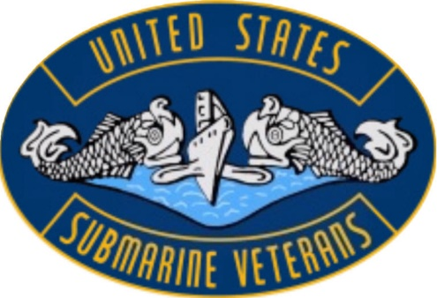
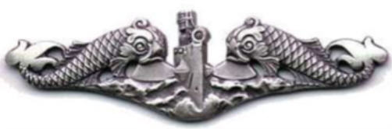

Presented by
The United States Submarine Veterans Inc
National Recognition Program
In Recognition of Outstanding Achievement
To:
Award Recipient

By completing the arduous tasks required to receive your Eagle Scout Award, you have demonstrated the qualities of leadership, honor, and devotion to duty and patriotism that place you head and shoulders above many young men and women today. By adopting the high code of ethics necessary to attain the Eagle Scout Award you have made the Scout Oath and Scout Law a part of your everyday life. You have set an example for other young Americans and made your parents, family and educators proud.
Presented by USSVI this Day, the Fourteenth Day of May 2022

________________________________ ________________________________
George Woods, Perch Base Commander
Jim Denzien, Eagle Program Chairman

